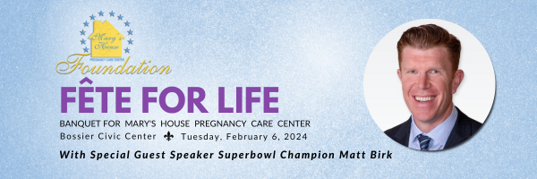

Platinum Sponsorship  $5000

Fete for Life Banquet

Tuesday, February 6th, 2024

Bossier Civic Center, 620 Benton Road, Bossier City, LA 71111

Paid with  Check #2107

Received from   Matthew and Roxanne Chumley    on  November 28, 2023

Thank you for being a Platinum Sponsor for the 2024 Fete For Life benefiting Mary's House!

Your Platinum Sponsorship includes 1 table for eight.  You and your 7 guests are invited to attend the VIP pre-party beginning at 5 p.m. with Matt Birk. Your name will appear on the website, in the program, social media and print.

We look forward to being with you and your guests on Tuesday, February 6th, 2024!

***Please note: the VIP pre-party begins at 5:00 p.m.  Dinner seating for the banquet begins at 6:00 p.m. and the event begins at 6:30 p.m.***

L'Anne Sciba

Director, Mary's House

*Mary's House Pregnancy Care Center*

*906 Margaret Place*

*Shreveport, LA 71101*

*318-220-8009*

[*www.maryshouseofla.org*](http://www.maryshouseofla.org/)